**Staff Objective Form**

|  |  |  |  |
| --- | --- | --- | --- |
| **Appraisal Year** | 2022 | **10 month follow up date review** |  |
| **Date objectives set** | 27-Feb-22 | **12 month appraisal date** |  |

|  |  |  |  |
| --- | --- | --- | --- |
| **Employee Name** | Sopheak Seng | **Supervisors Name** | Ms. Suong Chanlina |
| **Employee’s Position** | IT Officer | **Supervisors’ Position** | Finance & HR manager |

Objectives – necessary to achieve within the role (can be task, competence or project based)

| Step 1: Set objectives (between 4 and 6 meaningful objectives including how they will be measured) | Step 2: 6 monthly follow up review | | Step 3: 12 monthly appraisal | |
| --- | --- | --- | --- | --- |
| Employees comments | Supervisors comments | Employees comments | Supervisors comments |
| Asset Committee ICT   * Continue | Waiting for a final bidding and then update it into a new asset. |  |  |  |
| Website   * Continue | Complete a web platform – waiting for a supportive team which needs to get more information then upload it onto website.  -Website is replaced already. |  |  |  |
| Anti-virus   * Renew and set number of anti-virus that we needed * Purchase a new anti-virus if applicable | Renewed anti-viruses for all staff and purchased 10 licenses. |  |  |  |
| MS office365   * Set number of certain licenses * Change the annual plan if needed | Number of licenses is enough for the use already.  Annual plan is not yet set because wait for an approval. |  |  |  |
| IT Document for GADC Property   * Develop documents for signatory | These documents are already developed.   * Use of Gadc Resources that are Property of Gadc. * Use of Technology and Software Declaration. * Software Installation Requirements. |  |  |  |
| Server machine   * Setup a new server machine | This plan seems over budgets in the moment.  Waiting for an approval. |  |  |  |
| IT inventory   * Develop an inventory management system for GADC   **Note**: this will do in next year | This plan is for next year and need to discuss with supervisor whether gadc needs this database for the use or not. |  |  |  |

Behaviours/Values: Evidence of operating in a way that fits the values or behaviours expected

| Step 1: Set behaviours/values (no more than 4 meaningful including how they will be measured) | Step 2: 6 monthly follow up/probationary review | | Step 3: 12 monthly appraisal | |
| --- | --- | --- | --- | --- |
| Employees comments | Supervisors comments | Employees comments | Supervisors comments |
| Communication   * Talk face to face and details * Talk through electronic and details * Responding with an appropriate meaning & tone | This is ok – always practical |  |  |  |
| Team work   * Well-cooperated each other * Individual skills + help * Providing constructive feedback * Excluding personal conflict between individuals | This is ok – always practical |  |  |  |
| Respect   * Be kind * Be polite * Be thankful * Listen * Apologize * Compliment (the achievement of others) * Empathize with different perspectives | This is ok – always practical |  |  |  |
|  |  |  |  |  |

Development and Training

|  |  |  |  |
| --- | --- | --- | --- |
| Development Need | Ways to address | Agreed Action | Completion date |
| Support to work toward cisco qualification | Need to have a certain course |  |  |
|  |  |  |  |
|  |  |  |  |
|  |  |  |  |

**To be completed at the 12 month appraisal**

Overall Rating (Supervisor please tick)

|  |  |  |  |  |  |  |  |  |  |  |  |
| --- | --- | --- | --- | --- | --- | --- | --- | --- | --- | --- | --- |
|  | Highly Satisfactory |  |  | Satisfactory |  |  | Areas to Improve |  |  | Unsatisfactory |  |

Additional Comments:

Employee:

Sopheak Seng

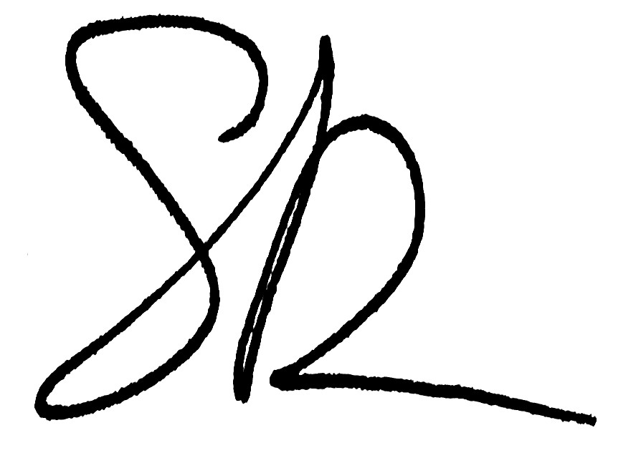

Signature: Date: 27-Feb-22

Supervisor:

Signature: Date:

Reviewed by:

(Print Name and Position – either Program Director or Supervisor’s Manager)

Comments:

Signature: Date: